Assignment 4

# question 1

Write a program called WolfvillePhoneNumbers.java which generates a random Wolfville number of the form:

902-542-XXXX

where the last 4 digits are random and in the range 0-9999.

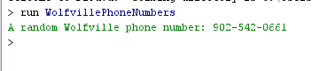

# Question 2

Write a program called WholeNumbers.java which solves PP 3.4 on p. 157.

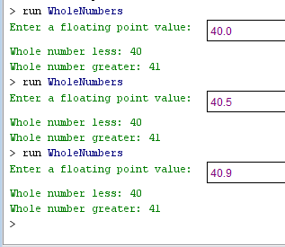

# Question 3

Write a program called Triangle.java which first reads in the (x,y) coordinates for 3 points of a triangle. Each x-y is an integer. Compute the triangle’s area. Use the formulas in PP 3.5 and 3.7.

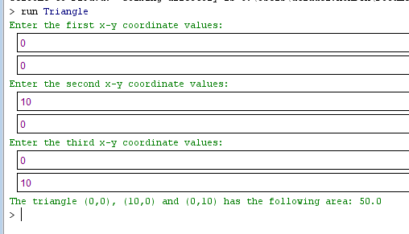

# Question 4

Modify the NestedPanels program in chapter 3. Call your program NestedPanels4.java. The modified program displays 4 nested panels. Each panel has a color, a label, and is 100 by 100. When your program is run it must first display the panels arranged as follows:

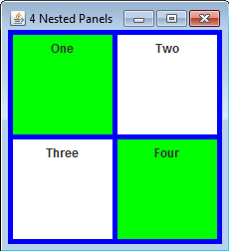

The window can be re-sized:

